HOLY CROSS CONVENT SENIOR SECONDARY SCHOOL,AMBIKAPUR

CLASS - IV
SUBJECT - ENGLISH GRAMMAR

Note: Students are instructed to write the following notes in their English grammar book with pencil.
Students not having the book can practice it in their English practice copy.

- NOUNS - GENDER

- GENDER
Nouns fall into four classes in terms of genders :
- Males
- Females
- Common (used for both)
- Lifeless

- MASCULINE, FEMININE
Read these sentences :
- The lion is the king of the forest.
- The lioness looks after the cub.
There are males and females among living-beings.
The noun lion sentence 1 is a male.
The noun lioness in sentence 2 is a female.
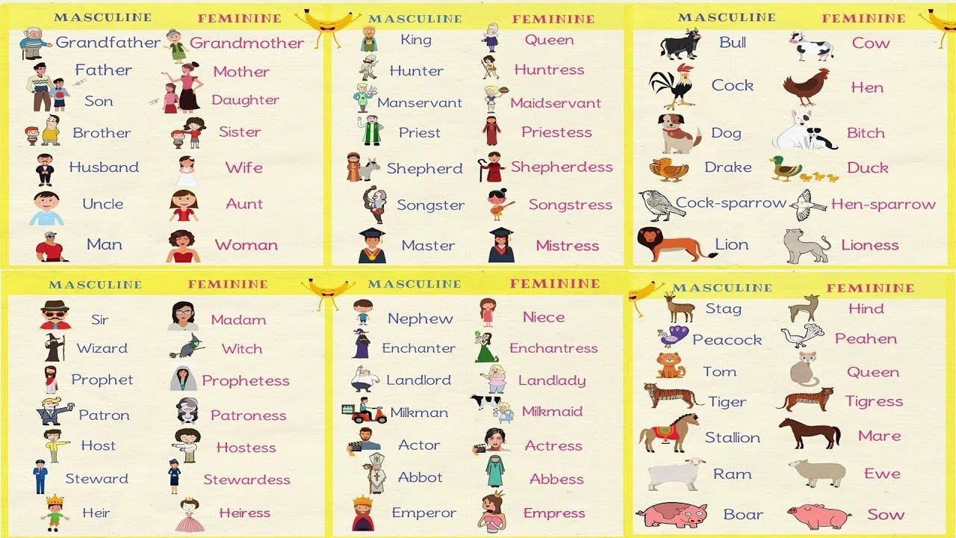

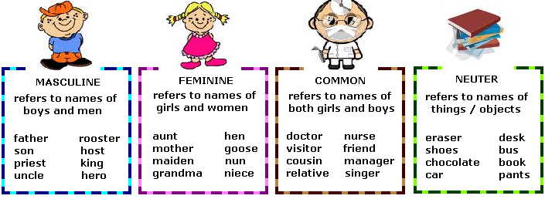

WORKSHEET

- Write the gender of each of the following nouns marking ‘M’ for masculine, ‘F’ for feminine, ‘C’ for common and ‘N’ for neuter genders:

House C | Chair N | Tree N | Actor M
Heir C | Stone N | Duke M | Book N
Friend C | Hunter M | Cousin C | Bird C

- Write the feminine gender of the following nouns:

Priest : priestess | Duke : duchess | Prince : princess
Bull-calf : cow-calf | Actor : actress | Heir : heiress
Traitor : traitress | Manservant : maidservant | Nephew : niece
Monk : nun | Sir : madam | Drake : duck
- Write the masculine gender of the following nouns:

Widow: widower | Sow: boar | Hen-sparrow: cock sparrow
Negress: negro | Goose: gander | Ewe: ram(sheep)
Hostess: host | Princess: prince | Governess: governor
Lady: lord | Countess: count | Tigress: tiger

- Rewrite each sentence changing the gender of the words in bold:

- This farmer has cows, buffaloes, he-goats and cocks.
This farmer has bulls, cows, she-goats and hen.
- Tigers, foxes, lions and peacocks live in forests.
Tigresses, vixen, lionesses and peahen live in forests.

- Write five nouns of common gender:

- Doctor
- Children
- Friend
- Cousin
- Relative

